ASSIGNMENT 2
Cloud Storage Implementation (Amazon S3)
Objective:
To set up a scalable object storage bucket and host a public resource.
Step 1: Accessing S3 Console
Amazon S3 landing page in the AWS Management Console. The "Create bucket" button is prominently displayed, which is the starting point for setting up a new storage container.

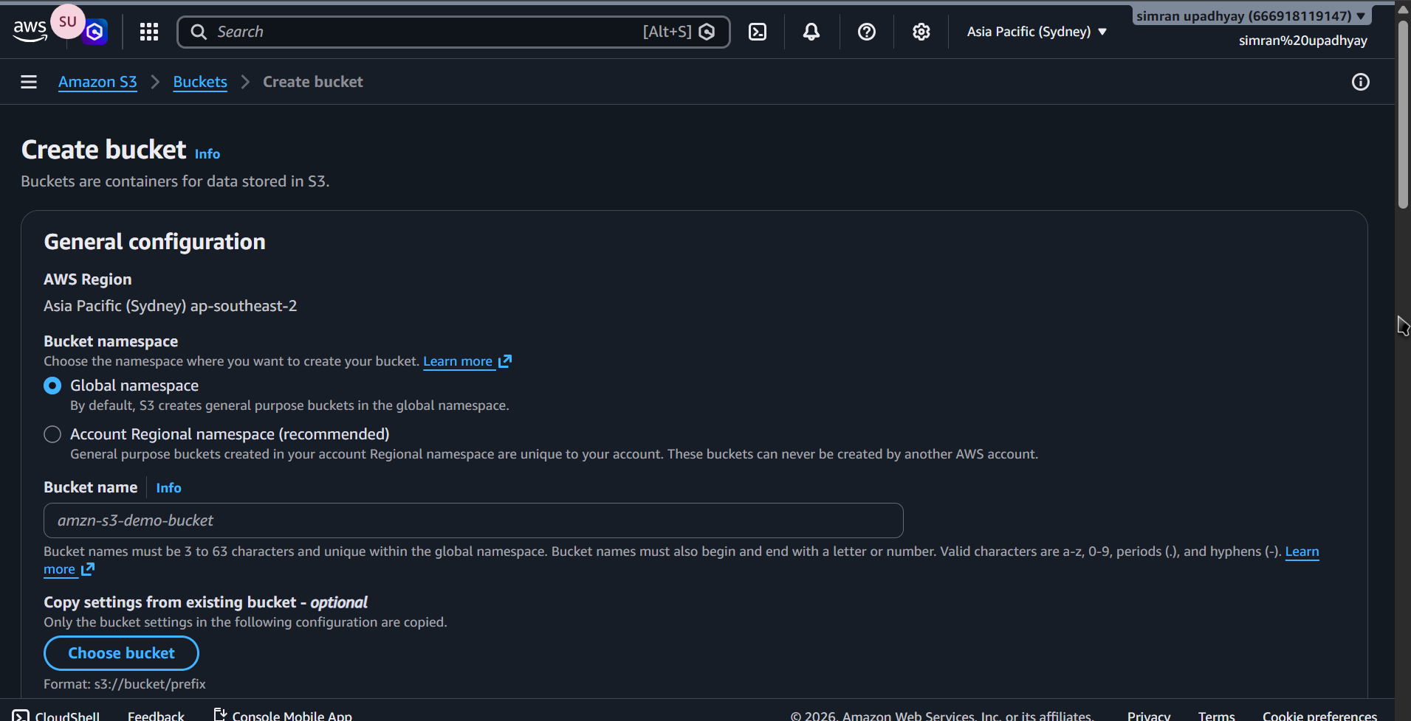
Step 2: General Configuration
The user is configuring the Bucket name as aws-s3-simran08. The AWS Region is set to Asia Pacific (Mumbai) ap-south-1, and the bucket type is selected as General purpose.
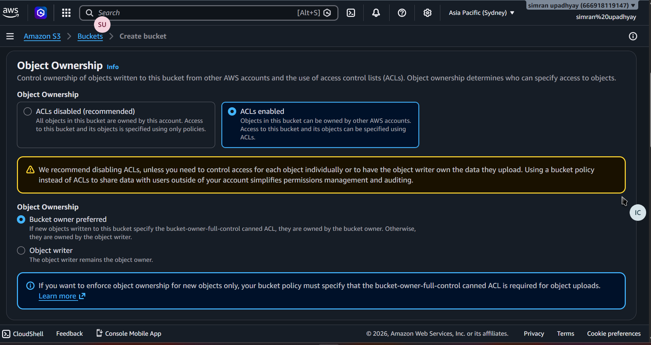
Step 3: Public Access Settings
The user unchecking "Block all public access." This choice is made to allow the bucket to be publicly accessible, and the user has checked the acknowledgment box to confirm they understand the security risks.

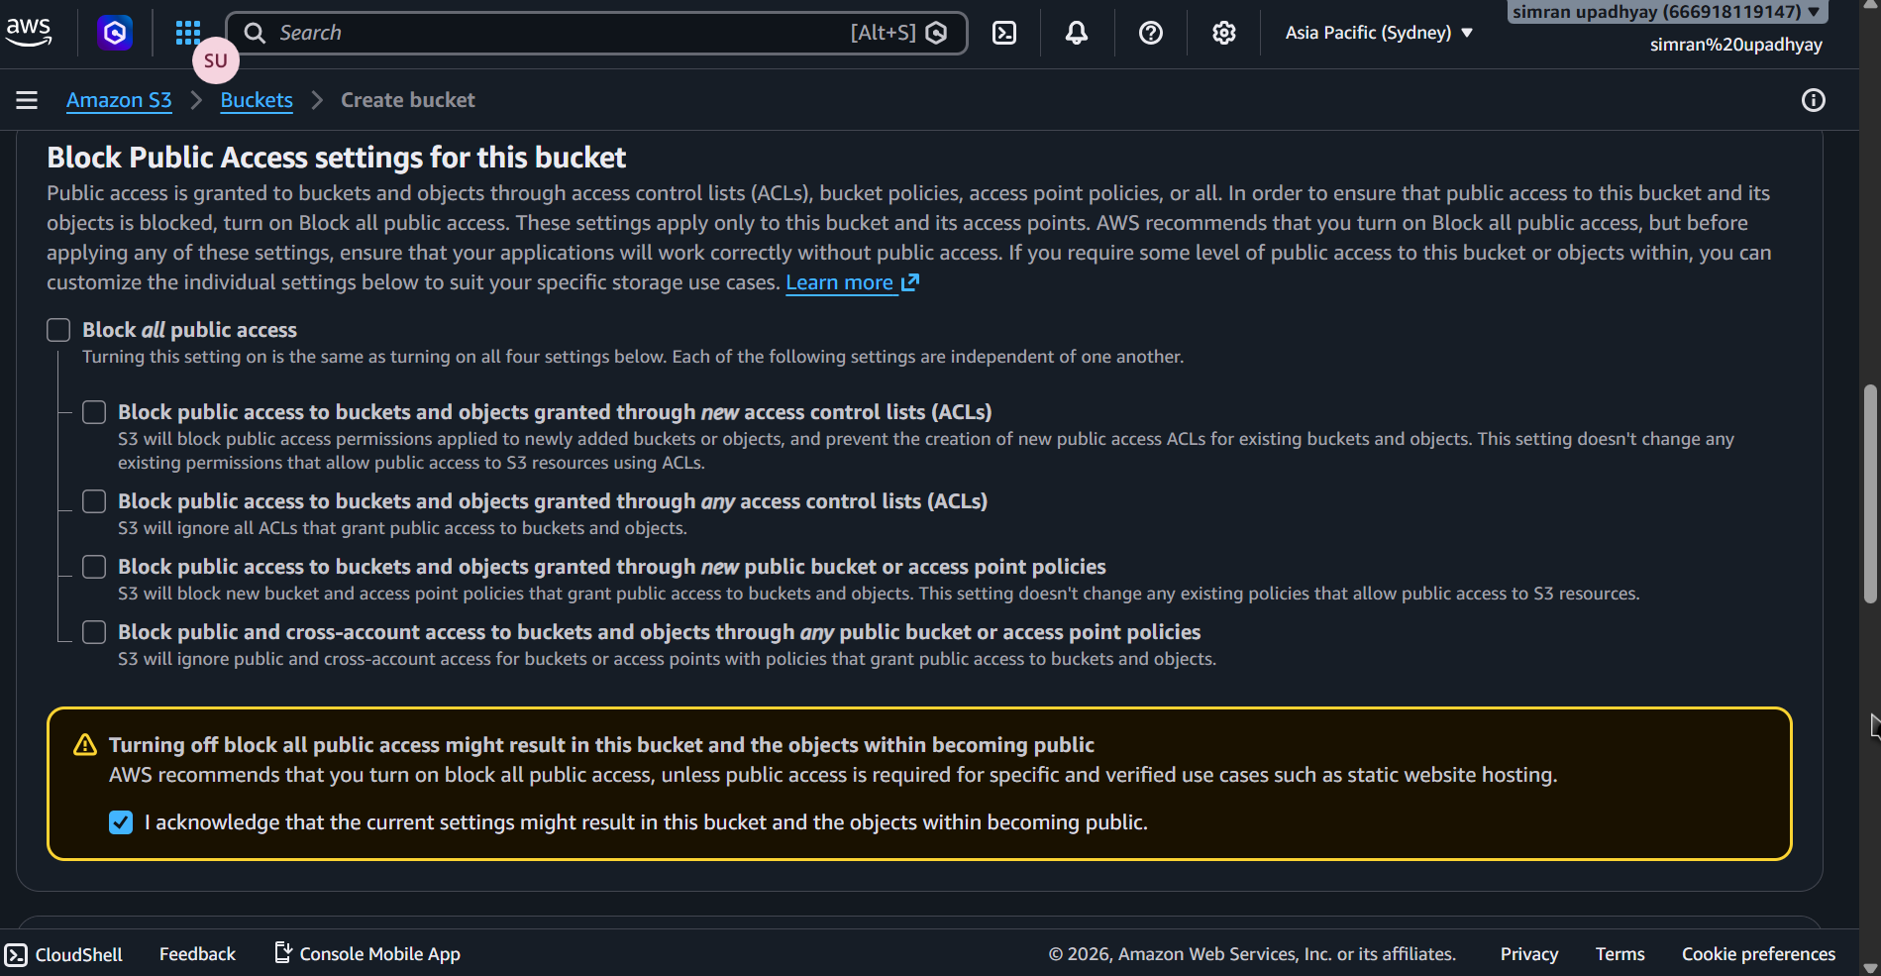
Step 4: Encryption Settings
The Default encryption settings. The user has selected "Server-side encryption with Amazon S3 managed keys (SSE-S3)" and has enabled the "Bucket Key" to reduce encryption costs.

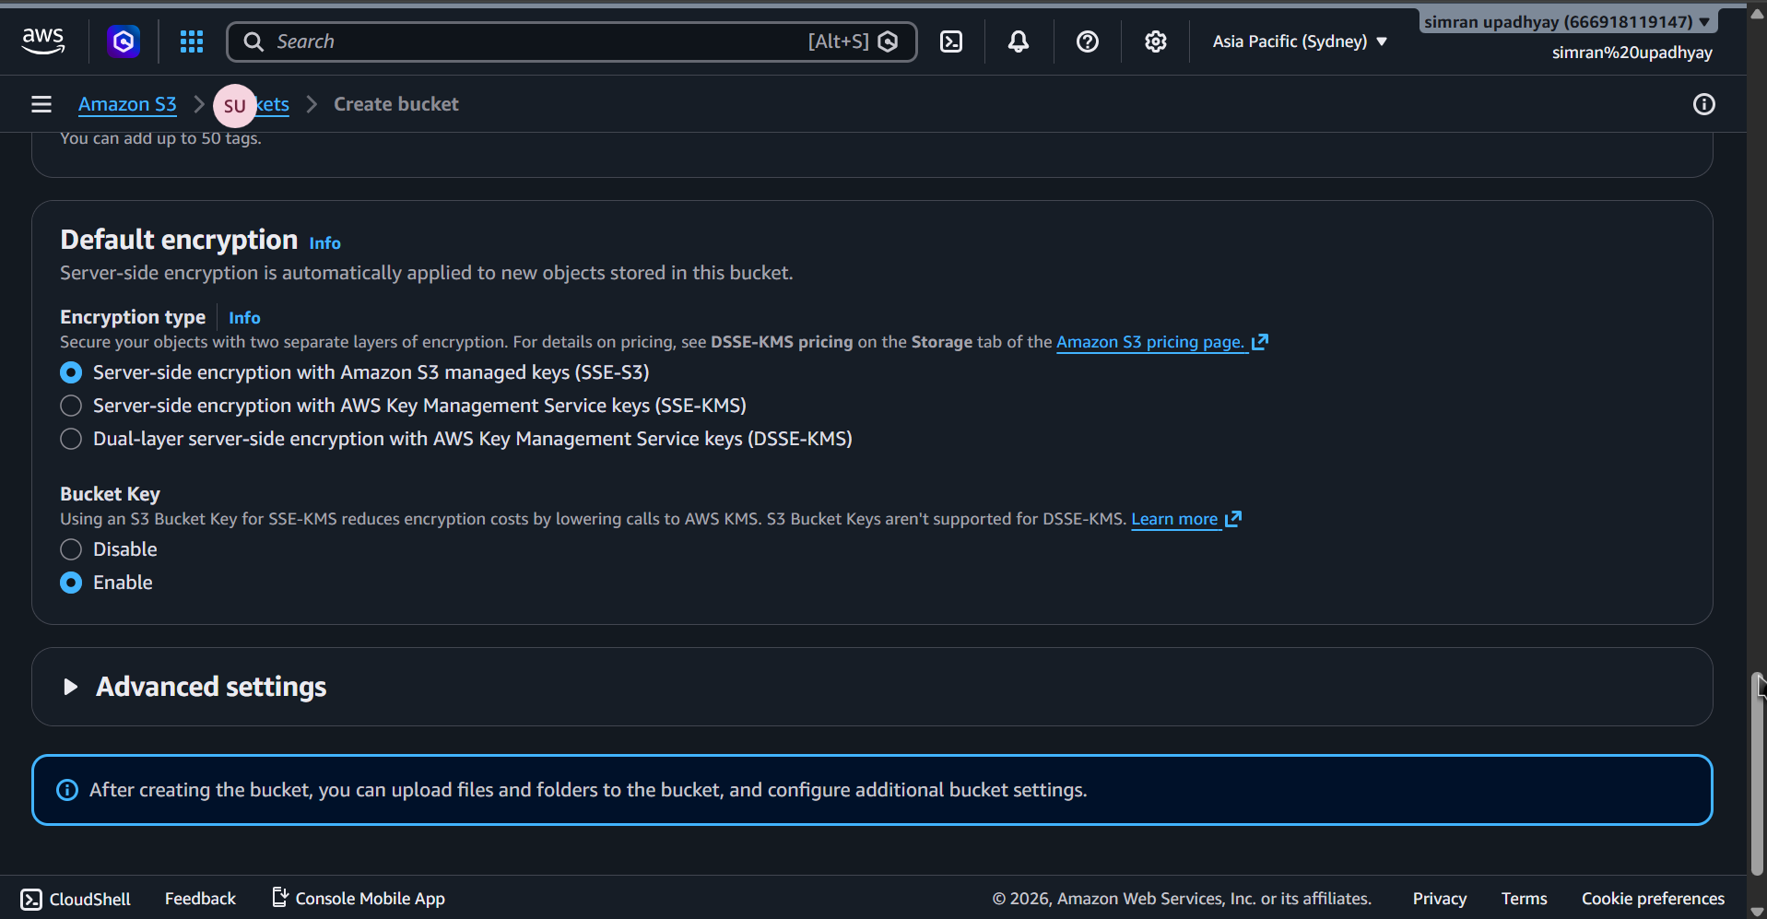
Step 5: Bucket Successfully Created
The green success banner stating "Successfully created bucket 'aws-s3-simrn08'." It takes the user to the bucket's "Objects" tab, which is currently empty.

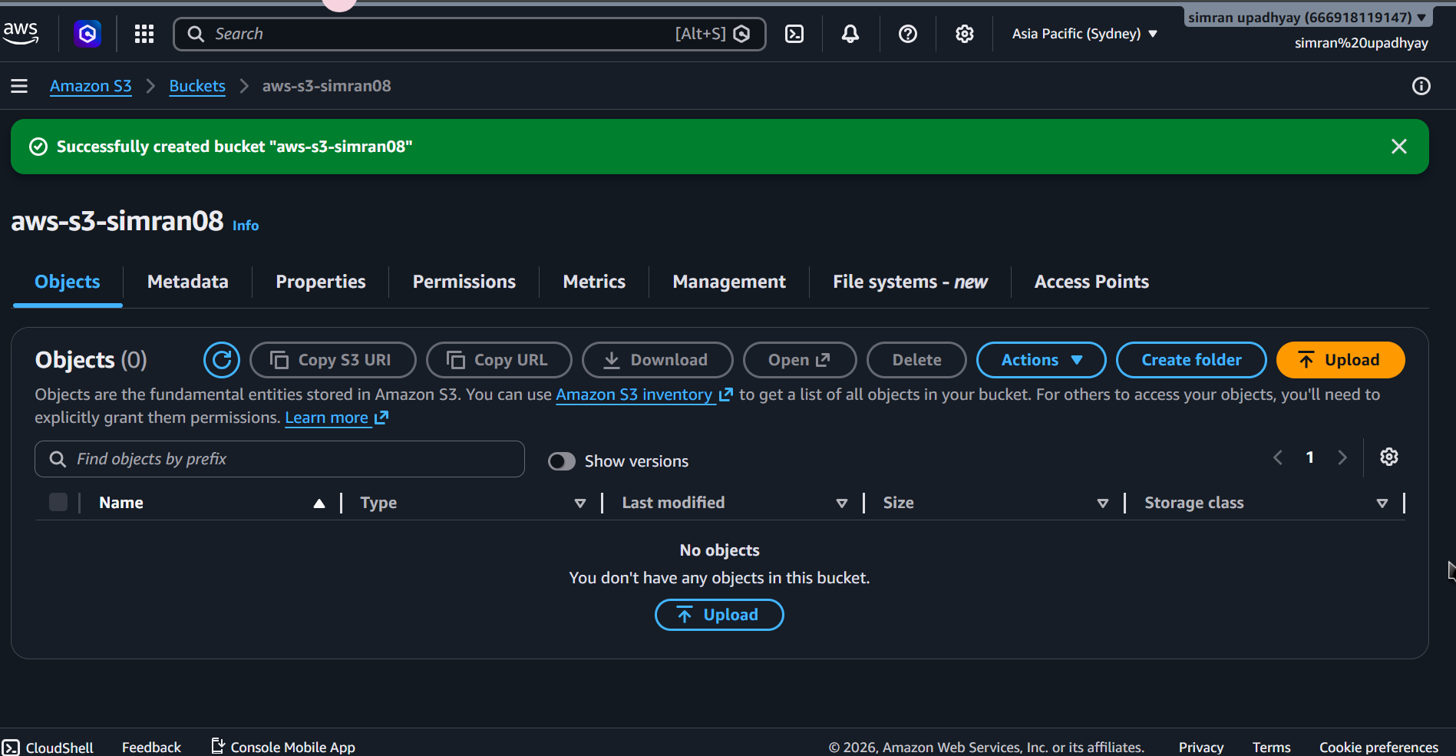
Step 6: Preparing File Upload
The user is in the Upload interface. A file named An Entity-Relationsh.png (821.6 KB) has been added and is ready to be uploaded to the destination bucket.
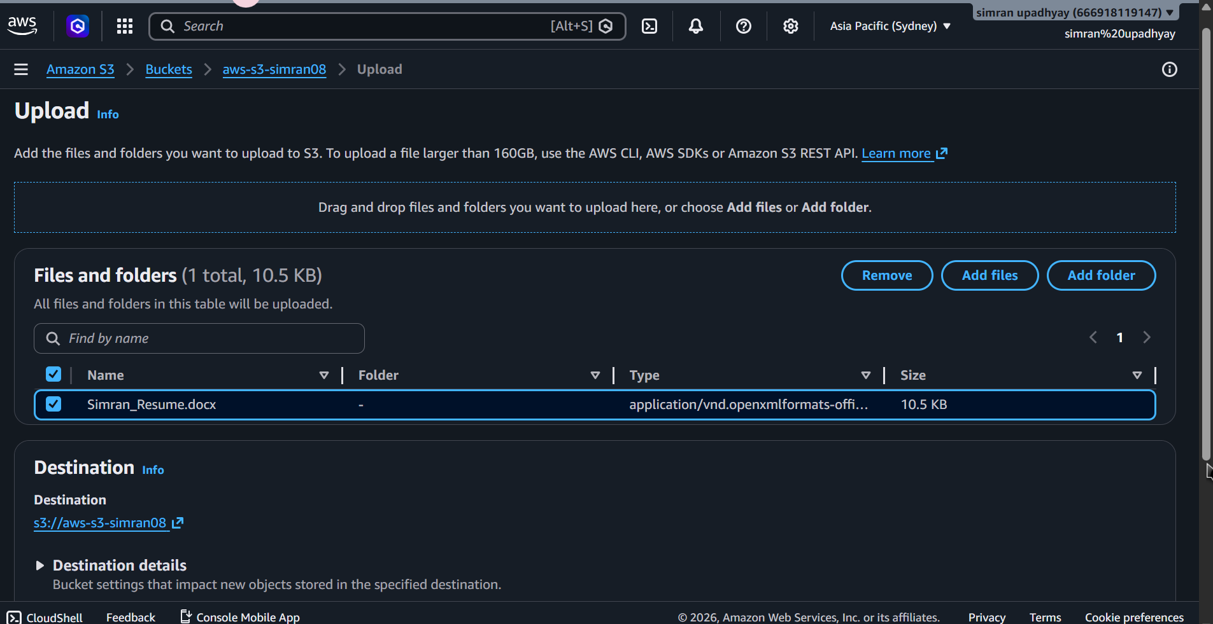
Step 7: Upload Successful
The Upload status page with a green banner confirming "Upload succeeded." It provides a summary showing that 1 file was successfully transferred with no failures.
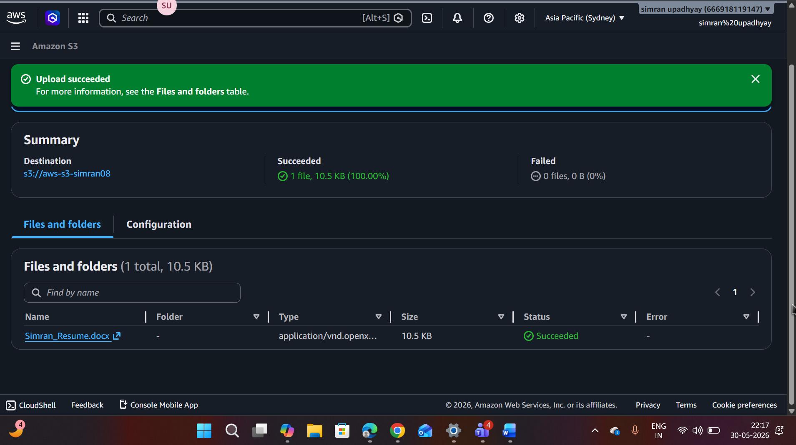
Step 8: Object Overview
The detailed properties of the uploaded image. It shows the Object URL, the S3 URI, and the Amazon Resource Name (ARN) required for referencing the file in policies.
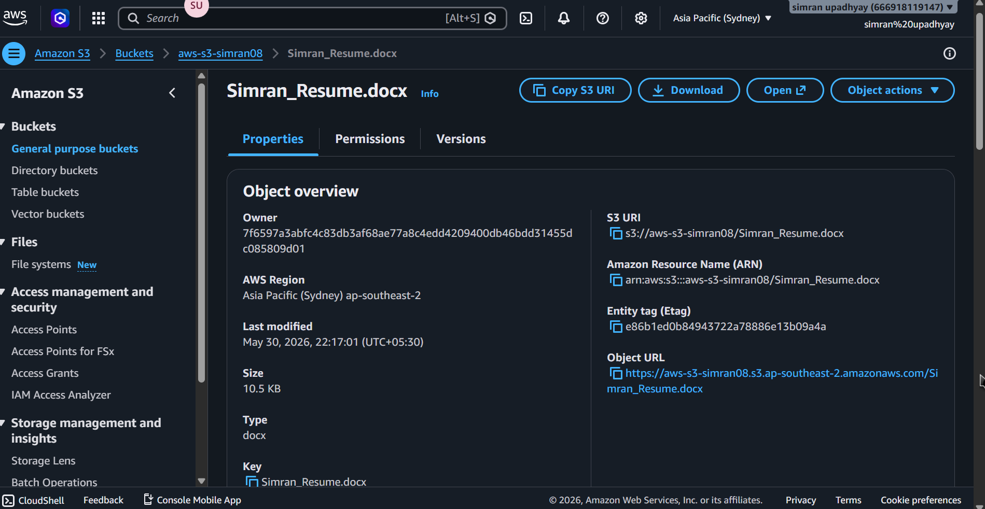
Step 9: Policy JSON Generation
The Policy JSON Document generated by the tool. It contains the code that grants public "Allow" permissions for the specific object An Entity-Relationsh.png within your bucket.

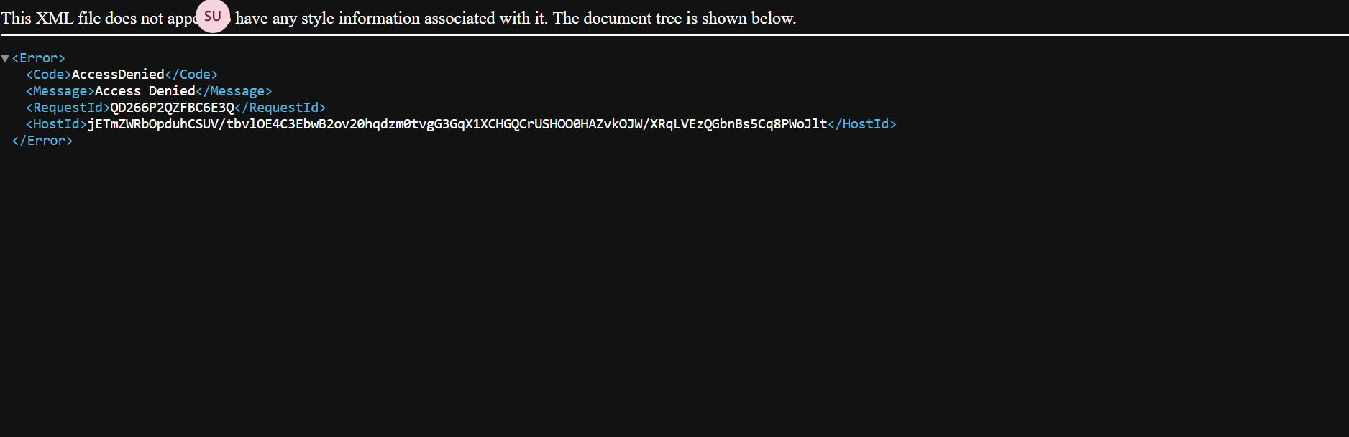
Step 10: Editing Bucket Policy
In you have navigated back to the S3 Console under the "Permissions" tab. You are pasting the generated JSON code into the Bucket policy editor to apply the security rules.

